8 Channel Rail RS485 Relay Manual
- 2CH RS485 Relay Serial HyperTerminal Enter:
http://v.youku.com/v_show/id_XMTM0ODY4NzkxMg==.html
- 2CH RS485 Relay Modbus Poll Enter(Usage 2-channel and 8-channel is the same):
http://v.youku.com/v_show/id_XMTM0ODY4OTg5Mg==.html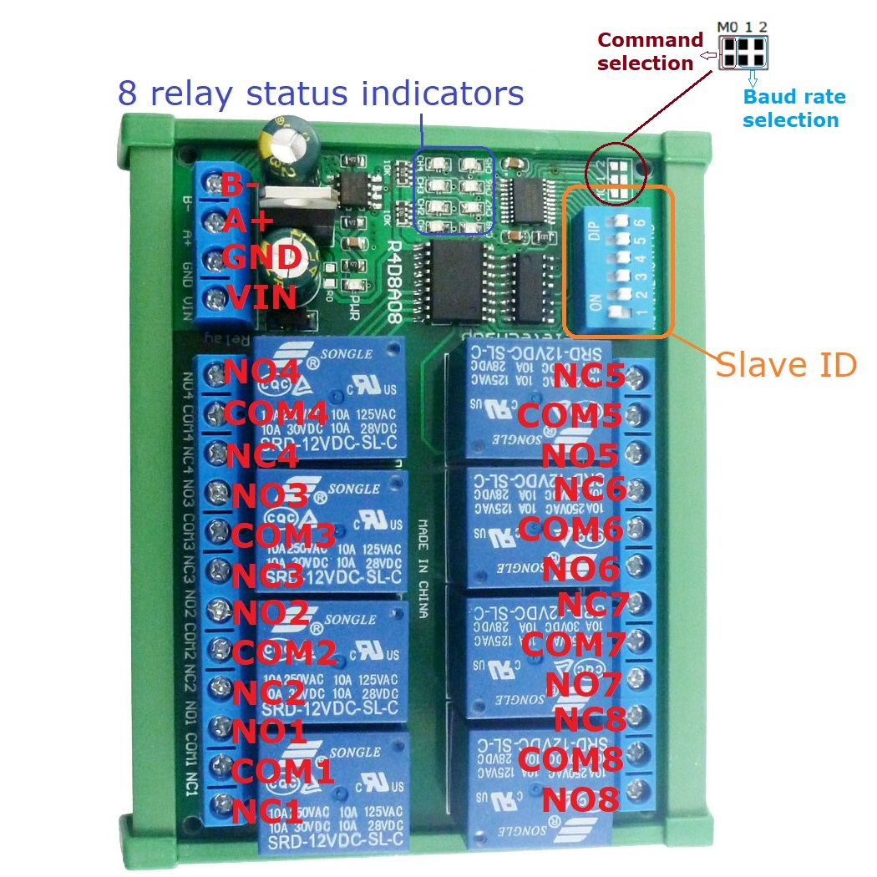
Features:
1: DC 12V power supply
2: Standby current (all relays closed) 12MA, 1 relay open 40MA, 2 relays open 68MA, 3 relays open 94MA,4 relays open 122MA,5 relays open 148MA,6 relays open 174MA, 7 relays open 198MA,8 relays open 224MA
3: "open" "close" "Momentary" "Self-locking" "Interlock" "Delay" 6 Commands
4: Two instruction-control mode : MODBUS RTU command and AT command
5: Under the "Delay" command ,the maximum delay is 255 seconds;
Under the AT command ,the maximum delay is 9999 seconds
6 MODBUS commands can be made serial HyperTerminal (serial assistant) OR "Modbus Poll" Enter; AT commands can be made serial HyperTerminal (serial assistant) Enter;
7 Under the MODBUS command mode, it can support up to 64 devices in parallel
8 The default baud rate is 9600BPS. The baud rate can be selected through jumpers: 2400 4800 9600 19200BPS
9 Size: 100 * 72 * 20mm(Only PCB Board);120 * 88* 42mm(with Din Rail Box)
10 Weight: 120g(Only PCB Board);198g(with Din Rail Box)
11 Maximum load: 10A / 250VAC, 10A / 125VAC, 10A / 30VDC, 10A / 28VDC, 10A / 12VDC

DIN rail Box parameters:
Product model: UM72
Color: green
Width: suitable for PCB board width UM72(72mm)
Insulation grade: flame-retardant VO grade
Backplane length: suitable for 100 mm PCB boards
Net weight: 72g
Installation: DIN35 and C45 rail

Glossary:
NO : Relay normally open contact
COM : Relay common contact
NC : Relay normally closed contact
Open : NO connection COM, NC disconnect COM
Close : NO disconnect COM, NC connection COM
Momentary : Enter the Momentary command, the Rreceiver Relay is Open, delay of 0.5 seconds after, Relay is Close;
Toggle : Enter the Toggle command, the Rreceiver Relay is Open, Enter the Toggle command again, Relay is Close;

Latched : Enter the Channel 1 Latched command, the receiver Channel 1 is Open, the Channel 2 is Close.
Enter the Channel 2 Latched command the receiver Channel 2 is Open, the Channel 1 is Close.
Enter the Channel 3 Latched command the receiver Channel 1 is Close, the Channel 2 is Close.

Delay : Enter the Delay command, the Rreceiver Relay is Open, delay of 0-9999 seconds(MODBUS command is 0-255 seconds )after, Relay is Close;
During the delay, Eter the Close command, immediately close the relay
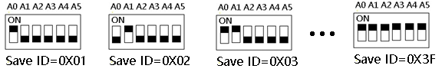
Slave ID: A0-A5 is the slave ID, you can choose 64 different slave ID.
Under the MODBUS command mode,the slave ID must be correct

1 This version has 2 Command modes, MODBUS RTU Command and AT Command. 2 The default Command is the MODBUS RTU Command, compatible with older versions.
3 Switch to AT command by shorting the M0 pad.
4 The default baud rate is 9600BPS. You can also select the baud rate by shorting the M1 and M2 pads.
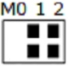 | 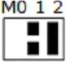 | 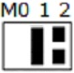 | 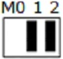
9600BPS(default) | 2400BPS | 4800BPS | 19200BPS

command Description, Please refer to "8 Channel Rail RS485 Relay commamd"

Typical applications:
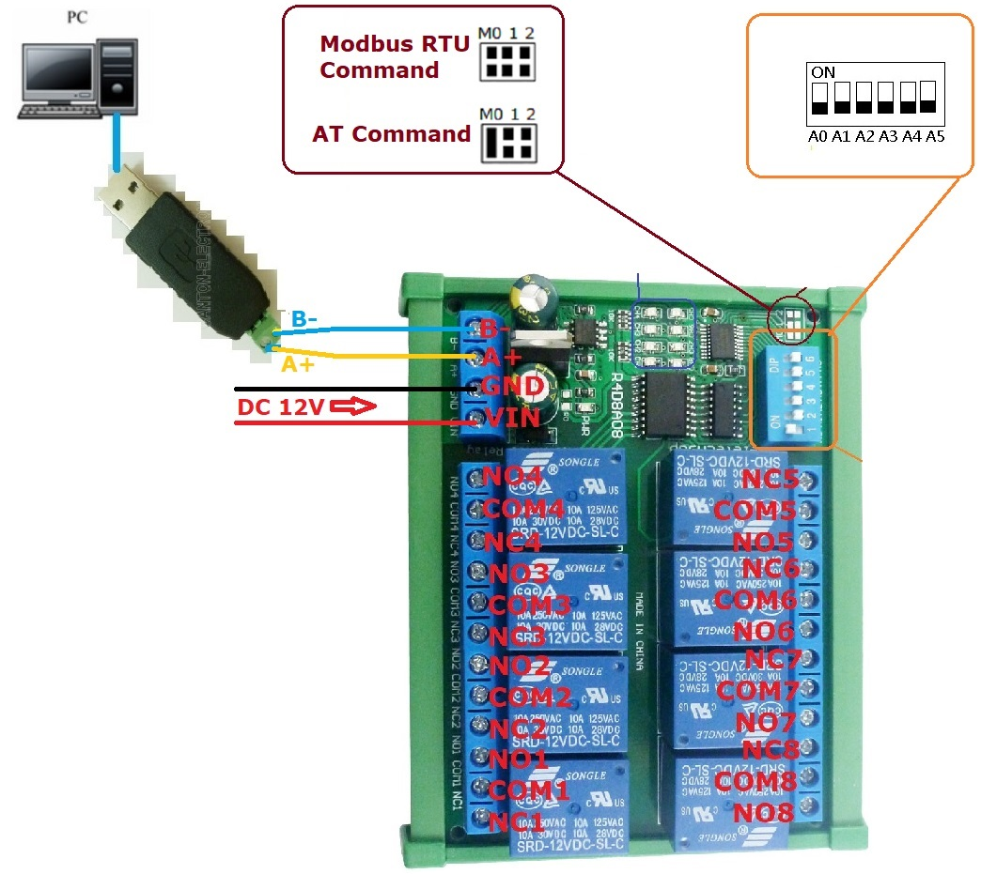
1 When controlling a module, you can use the MODUBS RTU instruction or the AT instruction. In AT command mode, the dial switch (slave address) is invalid and can only control one module at a time.

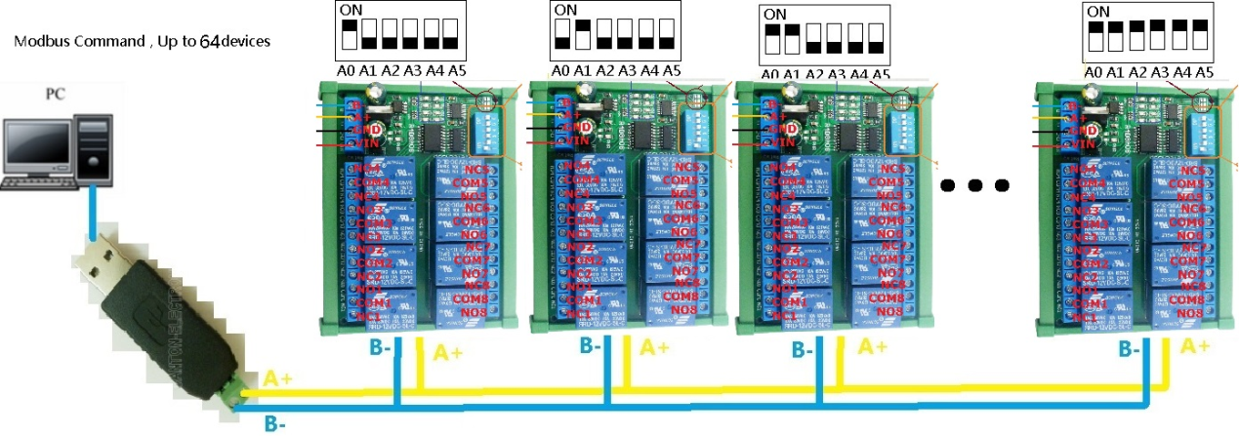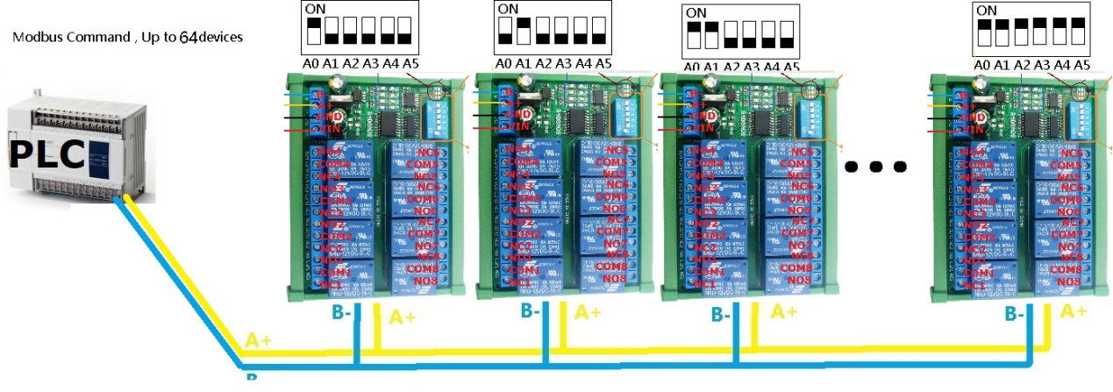

MODBUS command mode (HEX), you can control a variety of ways: Serial Hyper Terminal Control (need to manually add the CRC), Modbus Poll software control (software automatically add the CRC), PLC or MCU process control

Wiring Diagram:
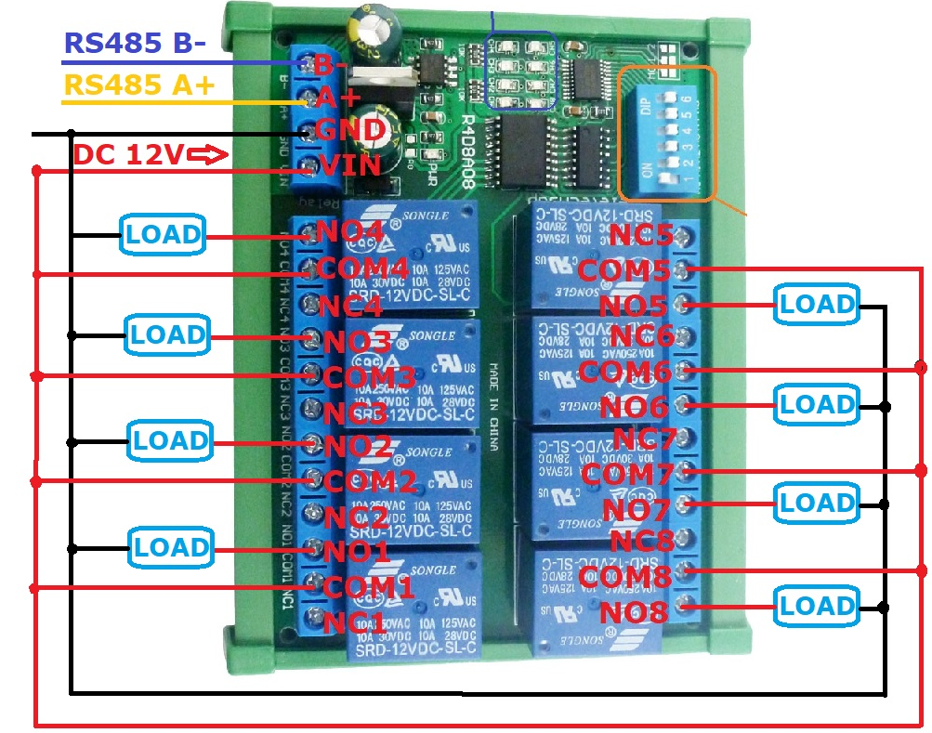
1 DC 12V control circuit,Wiring diagram below. "LOAD" may be camera,LED lights, fans, motors and other DC 12V equipment
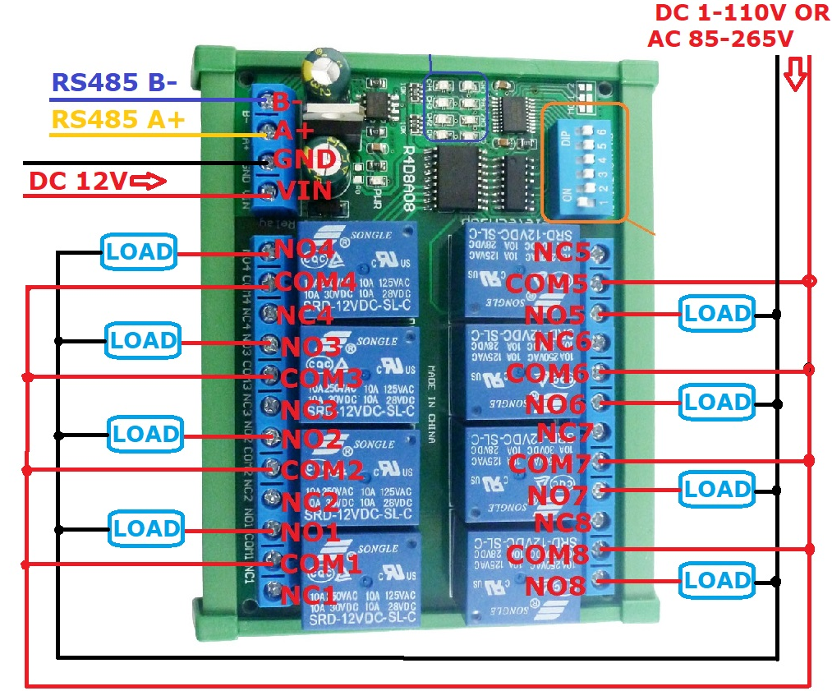

2 DC 1-110VAC 85-265V control circuit,Wiring diagram below(Note:If not DC 12V load, need another DC 12V power supply). "LOAD" may be LED lights, fans, motors Lights, fluorescent lights, solar water heaters and other DC AC equipment

